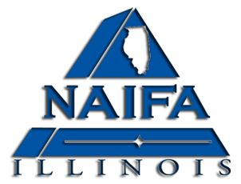
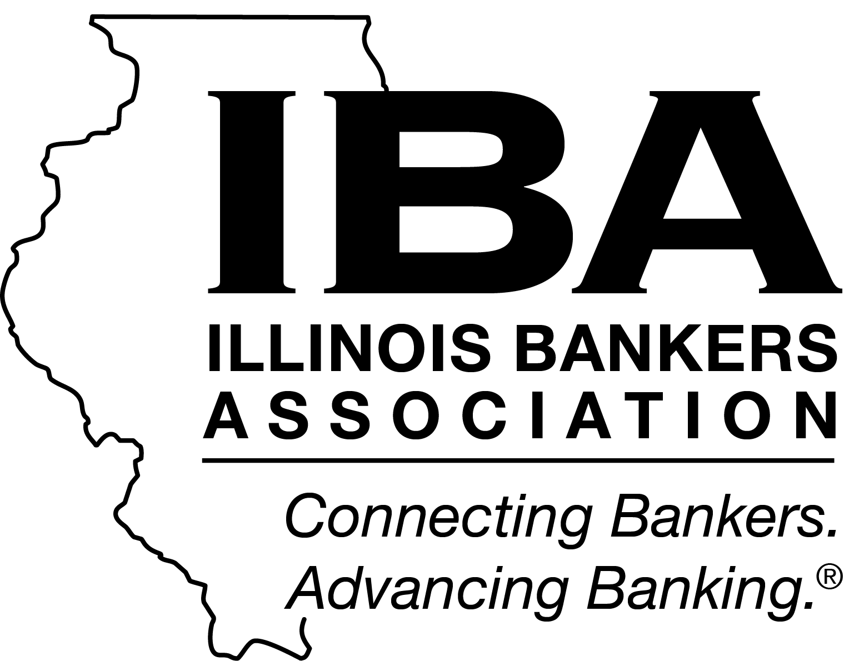
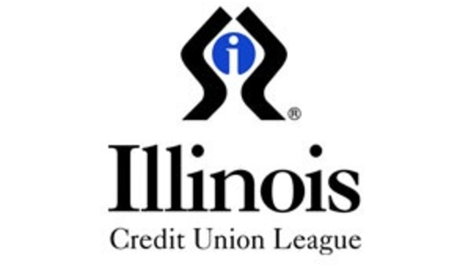

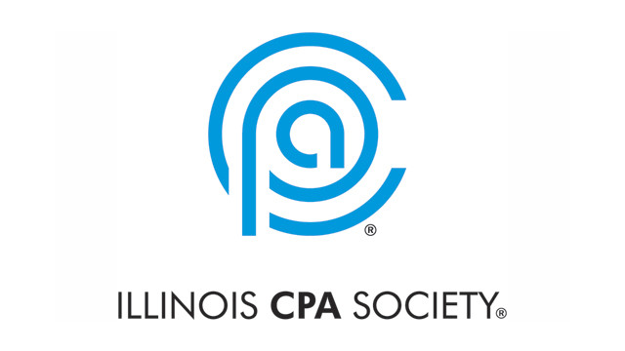
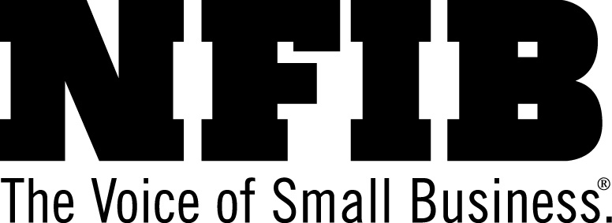
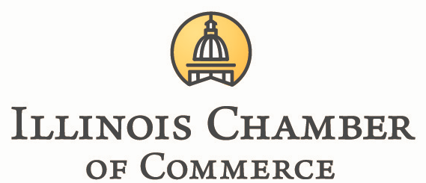

Oppose Massive 400% Tax Increase on Illinois’ Vital Financial Services
VOTE NO ON HB 4293 (Welch)
______
Summary:
In today’s interconnected world, billions of dollars travel across the globe in less than seconds. HB 4293 (Welch) would put Illinois’ vital financial service sector and the tens of thousands of jobs it employs at risk by imposing a new 20% gross receipts tax on partnerships and S corps engaged in the business of conducting investment management services. Illinois has benefited from being a top ten globally-recognized financial hub. HB 4293 would hurt our state’s global reputation and would force investors to look to less hostile cities such as Boston, Dallas, and Charlotte.

Business opposes these bills for the following reasons:

- Start-ups continually face shortages of capital, and raising taxes on investment management services provided to Illinois based start-ups would reduce investment options for private companies, innovators and small firms getting off the ground.

- Illinois is home to many investment partnerships. If this tax were adopted, Illinois could likely see part of its financial sector leave for other states where taxes would be far lower.

- If Illinois taxes on such income were to increase, this form of private investment would shrink, and many Illinois businesses would lose access to capital and expertise.

- Lower federal taxes on capital gains encourage private equity and venture capitalists to supply the financial capital and business expertise that are essential for investments that spur innovation, improve productivity and expand capacity.

- Illinois should not attempt to address a perceived inequity in federal taxation at the state level. This legislation is designed to offset the lower federal tax rate imposed as “carried interest.” Any such change should be done at the federal level.

- The tax will likely be subjected to a constitutional challenge as an improper second income tax, or a tax that violates the uniformity clause of the Illinois Constitutional by unreasonably signaling out a particular industry.

We respectfully urge a NO vote.

